Rodrigo Brasil 10/2023

### **Part 1: DNS**

Select add roles and features

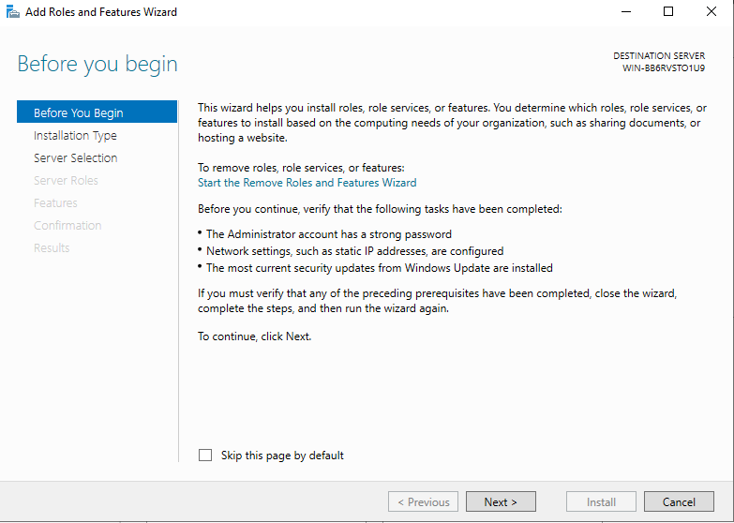

click next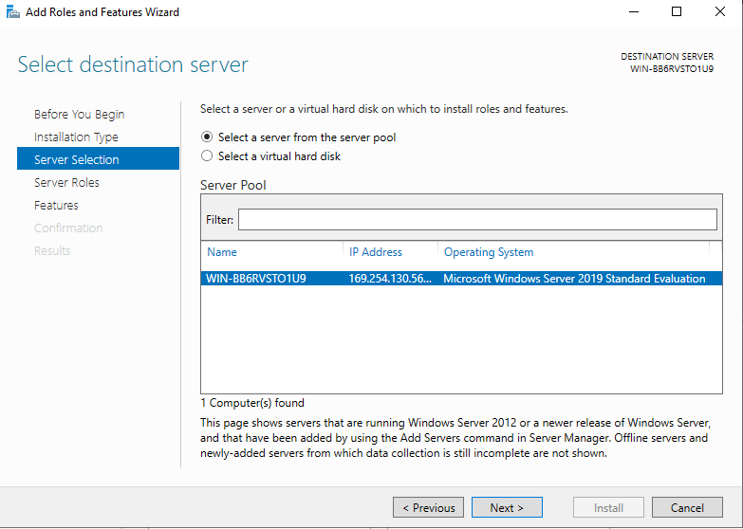

Select your server

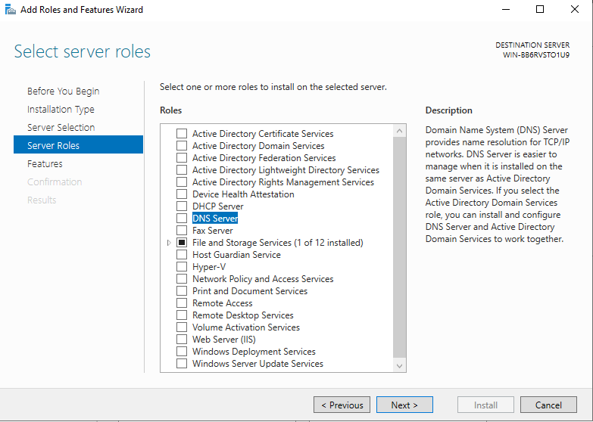

On server roles select DNS server

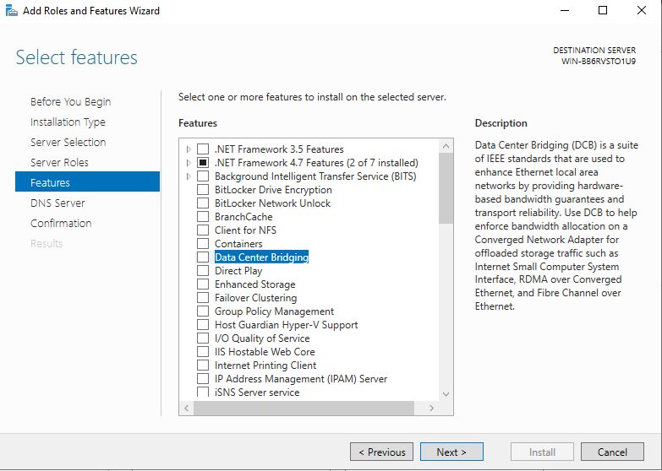

No feature is needed so skip this part by clicking next

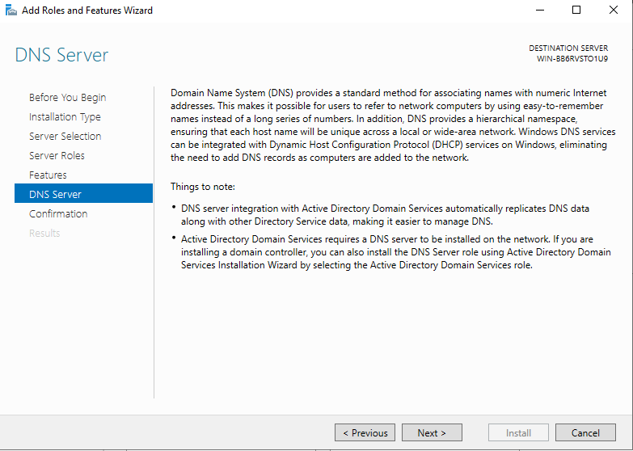

Indicates what DNS is and what its purpose is

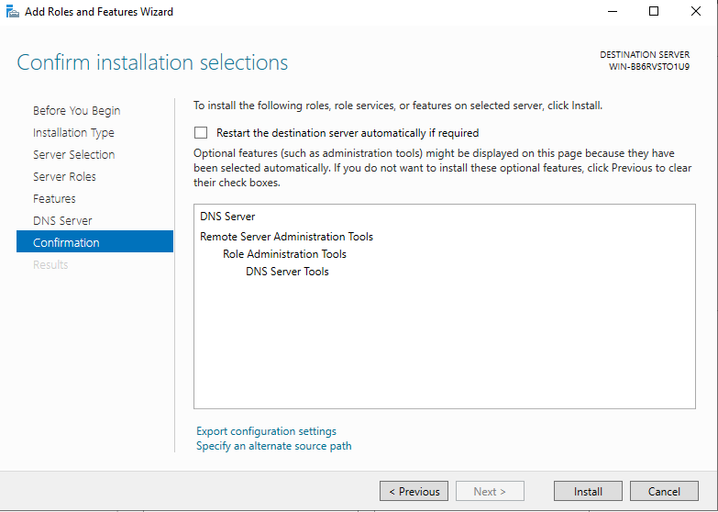

review the selected role, if it’s correct click install

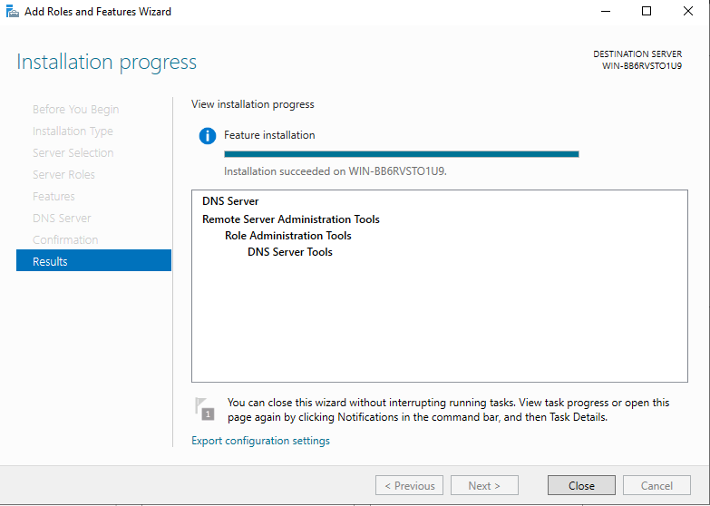

Installation finished

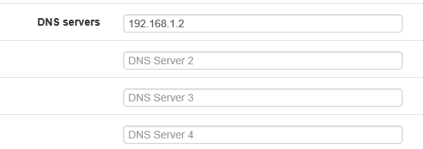

scroll a bit down until DNS servers is found and type the Win Server IP

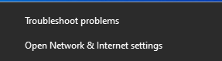

right click the internet symbol on the lower right corner of the windows desktop and select “Open Network & Internet settings”

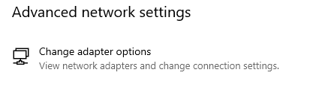

click “change adapter options” to show the connected adaptors

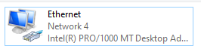

double click your internet adapter

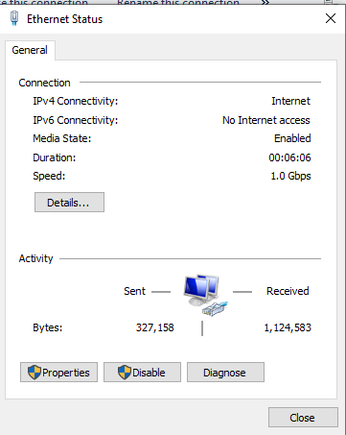

Select “Properties”

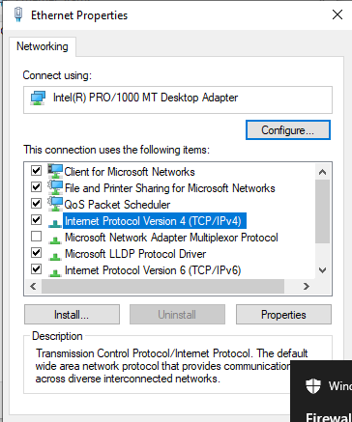

double click the “internet protocol version 4 (IPV4)”

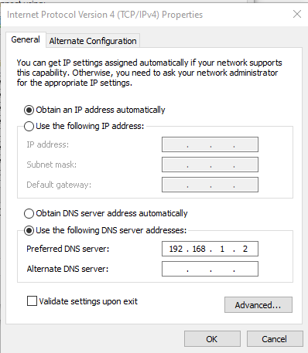

select “use the following dns server addresses” and give it the Win server ip

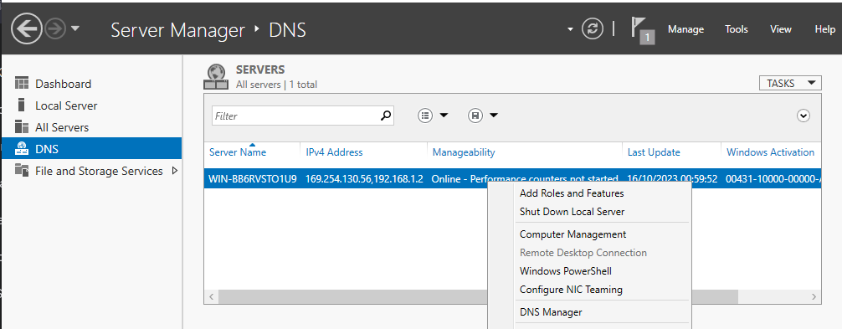

right click the server in the DNS menu and select DSN Manager

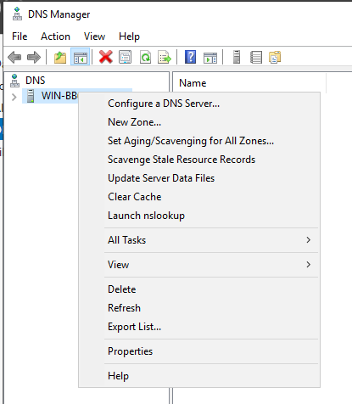

right click the server and select new zone…

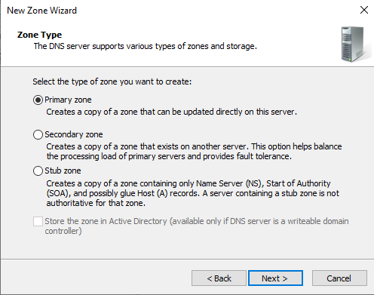

select primary zone

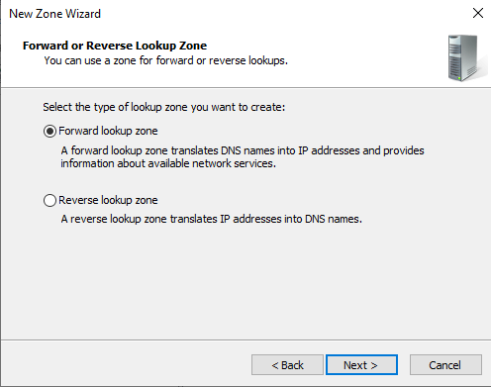

select forward lookup zone

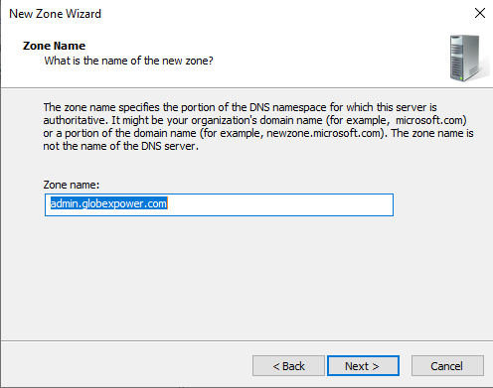

give the zone a name in this case will be globexpower.com

(zone name in the figure is wrong)

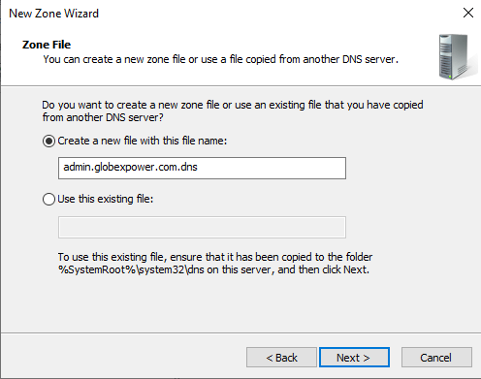

Create a new zone file, by default it will give it the zone name with the extension .dns, you can leave it as is

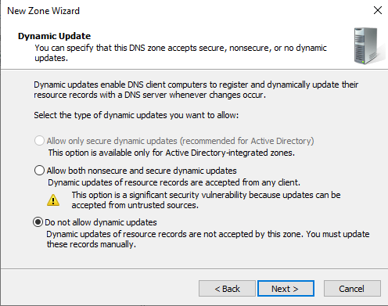

leave it default (do not allow dynamic updates)

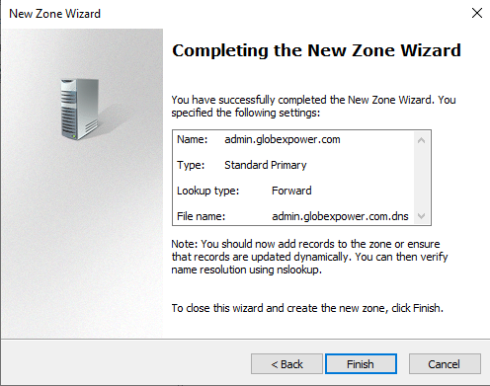

The new zone is created

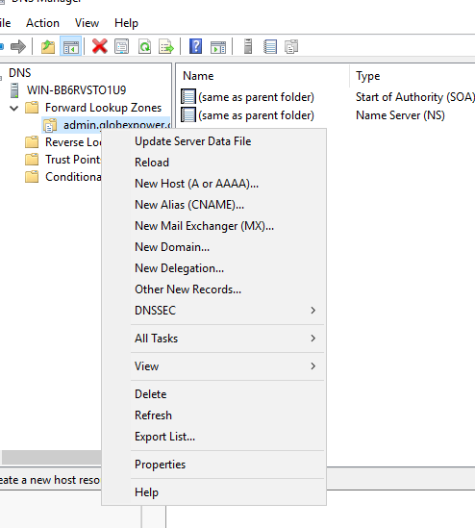

Right click the created zone and select new host (A or AAAA)

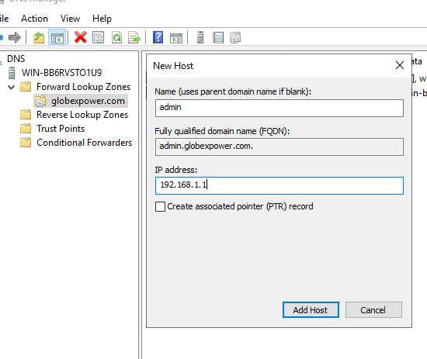

Add a name and ip address to the new host A (ip should be in this case pfSense)



Host A created

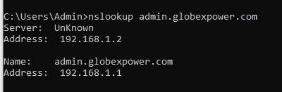

Successfully resolved

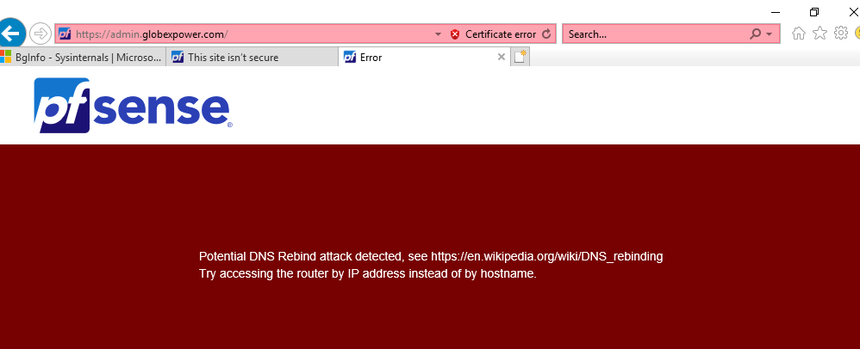

If pfSense is accessed with the domain it gives an DNS rebind attack detected warning

### **Part 2: Active Directory**

Same as before for the DNS but now we are going to chose “Active Directory Domain Services”

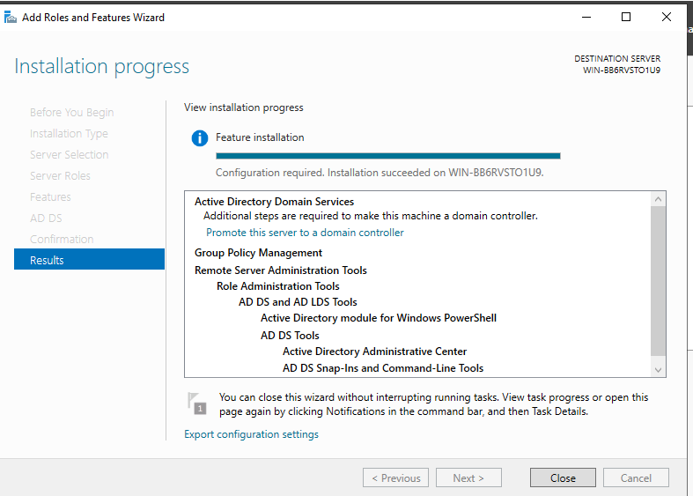

Active Directory Installed

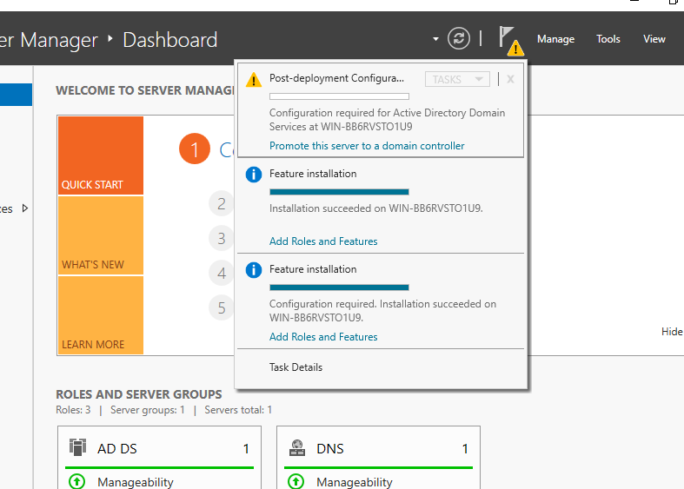

A notification will show up, click on it to promote the server to domain controller

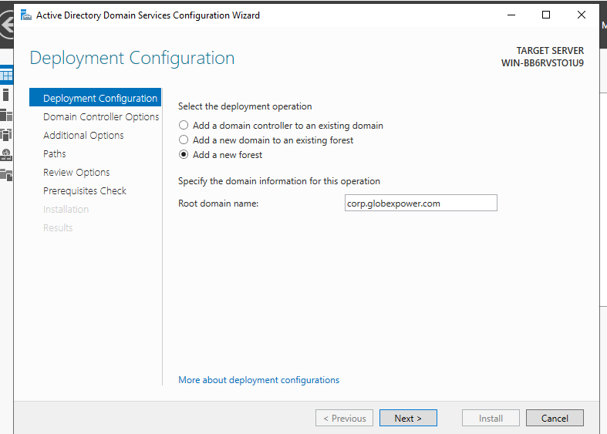

Select add a new forest and give it a root domain name

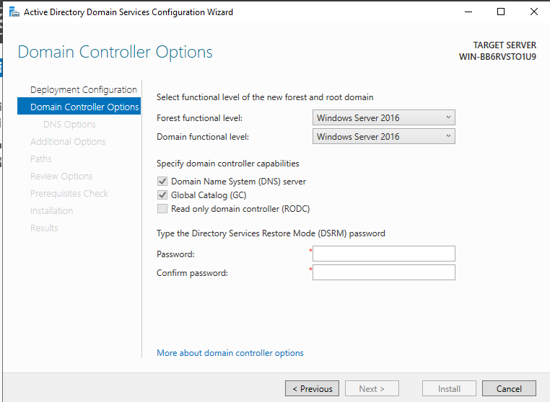

Create a DSRM password in our case it will be “!GlobexPowerAD1”

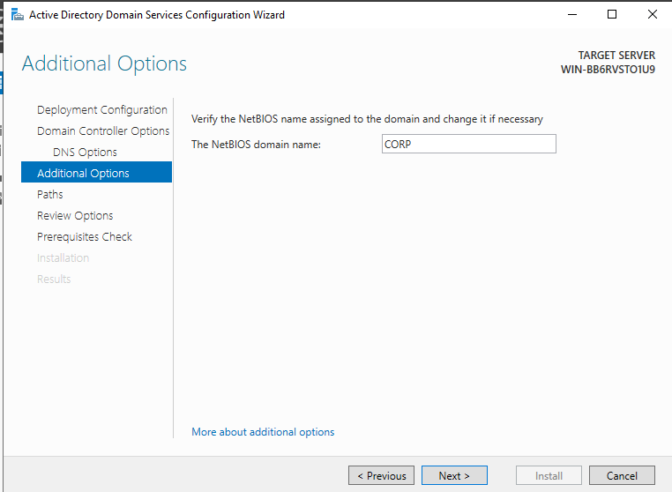

Enter a NetBIOS domain name in this case it will be CORP

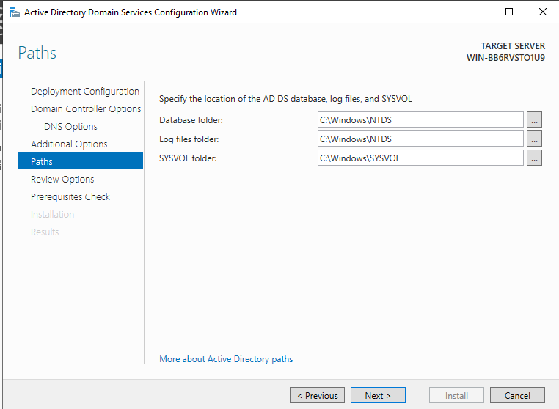

we will leave the paths at its default

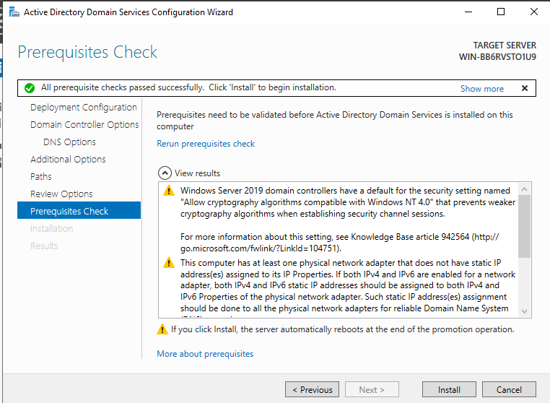

It will make a prerequisites check, to see if we have everything necessary and install.

after installing it will reboot by itself.

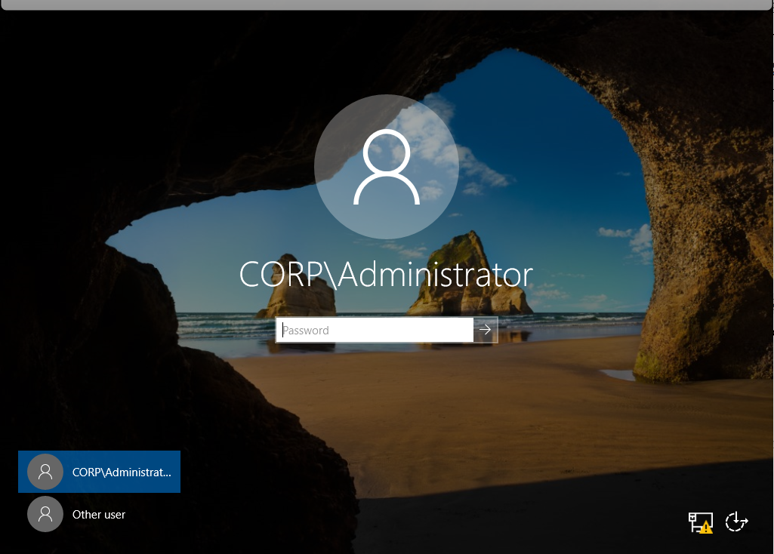

Login with your normal password

### **Part 3: BgInfo**

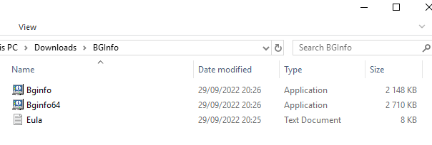

Download and run Bginfo64

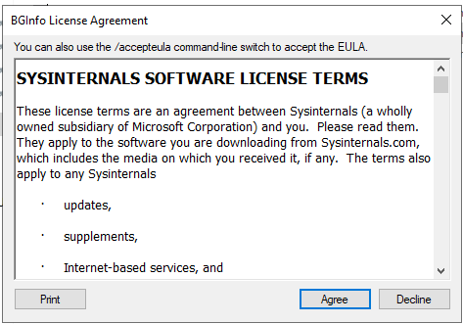

accept its terms and conditions

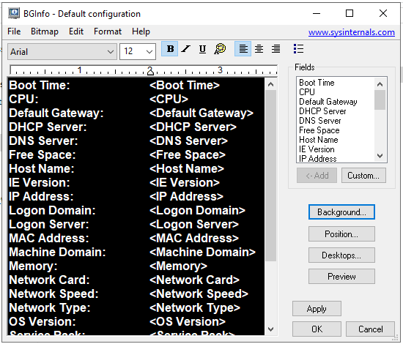

Customize it or leave it at default, and click ok

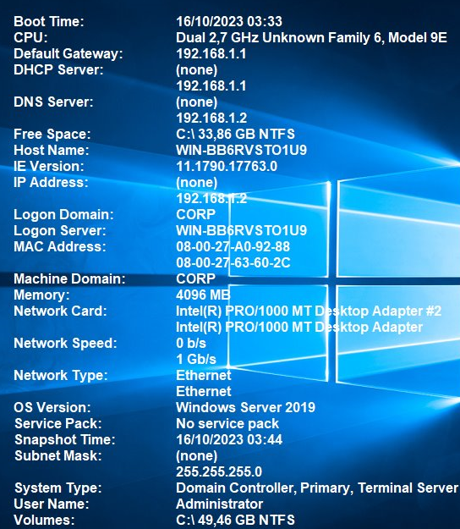

Now it displays all of the server’s info

To start automatically at boot

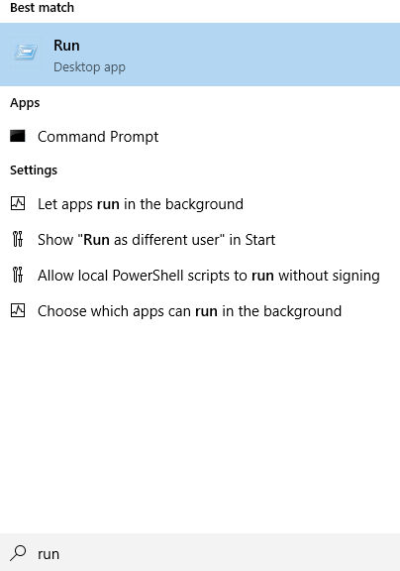

Search for run

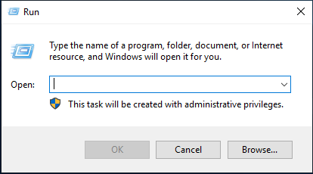

and type “shell:startup”

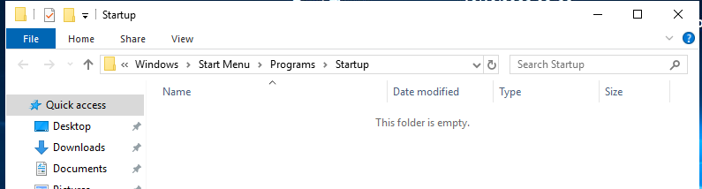

it will open this folder

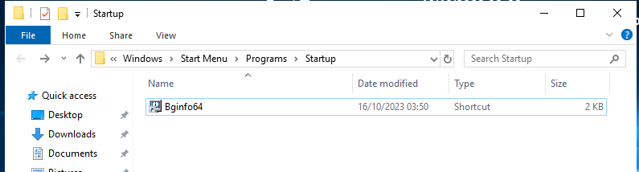

Create a shortcut of Bginfo64 and move inside the folder to start it up upon login

### **Part 4: Topology**

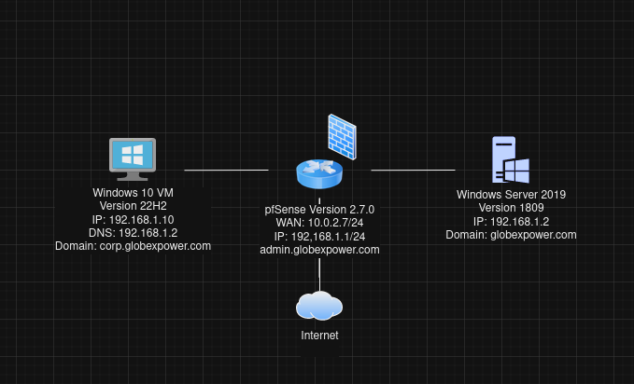

Final Topology